Present ideas on possible themes to set the game in. Think about possible game characters that relate to the theme.

Present 6 ideas to the group for next week.

Games Theme Ideas –

1. **Sky Dudgeon theme:**

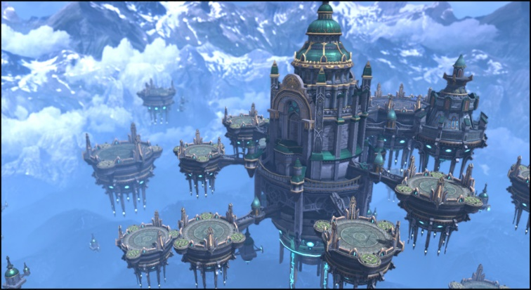The game could be set the clouds where the main character will have to progress through the dungeon by getting through each level where at the end it could include an escape to an exit which contains an aircraft that will take the main character away.

The story line could include a character visiting a sky castle where he is willing to meet the king of the land but in actual fact it’s a dudgeon that is used to keep people that enter inside so that they cannot see the king as it is actually an enemy base disguised as the castle in which the king lives.

The levels could include see through floors that enables players to see the clouds and land below the levels will contain assets such as walls, pillars, barrels and traps such as spikes.

The Character that could be included in the game could be a sky warrior type design that has mission to report important information to the king that entails details on a rebellion.

1. 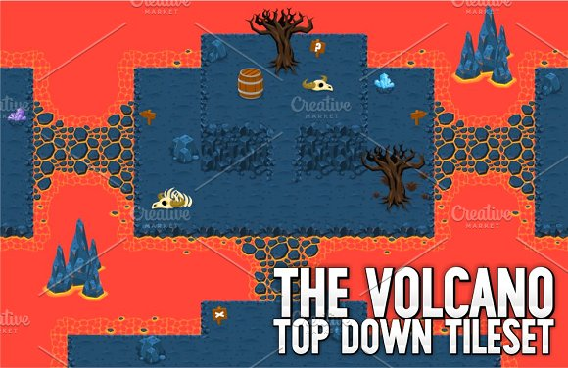**Volcano dungeon**

This design would include levels that include assets which relate to a volcano type theme and lava that surrounds parts of the platform that the character can move on. The fire can also block some of the levels so the players will have to find a way around the lava to escape the level.

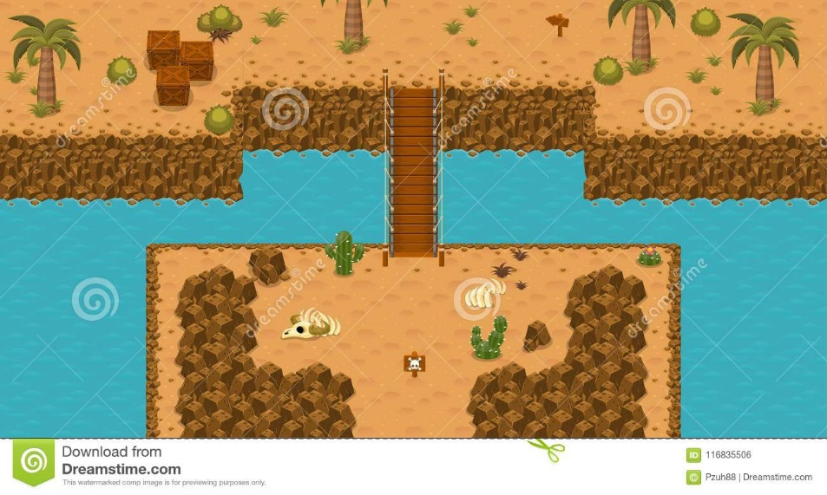The level can include the main character being a skeleton type character that is trying to get through the volcano into the after life where he can leave the world into a much cooler place.

1. **Lost/ deserted / tribe island**

This design contains a sandy type level as the character is this design would have become stranded on this island where he needs to find if there is anything or anyone on the island that can help him escape and get back to main land each level is a puzzle and eventually leads the main character to a thick forest.

The character in this design could be a pirate or a human being who has had their boat over turned which crashed into this island.

1. 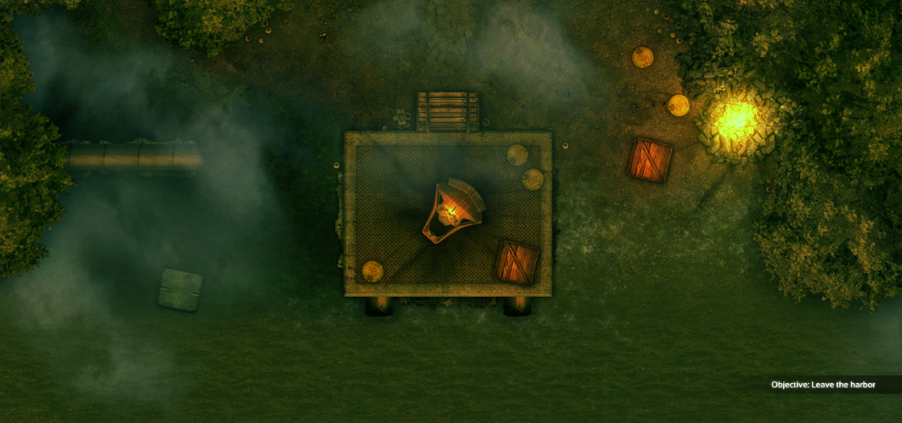**Jungle escape**

This game design idea could include a soldier who is coming back from a war zone, while on the way back to his base his helicopter crashes into a deep spooky thick forest where he will have to go through different levels to find his way through the forest to find his main based and to get back with the other soldiers that were coming back from the war zone.

The idea can include vines that blocks parts of the level which tells the player that they need to find a route that will get them onto the next part of the game.

The character could progress through each of the levels by sliding to boxes that are left over from the war plus trees in the level so that the character can escape the level and continue in the direction his war base is said to be. The main character will have a compass saying what direction he is going in.

1. **Underground mine**

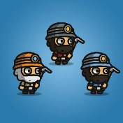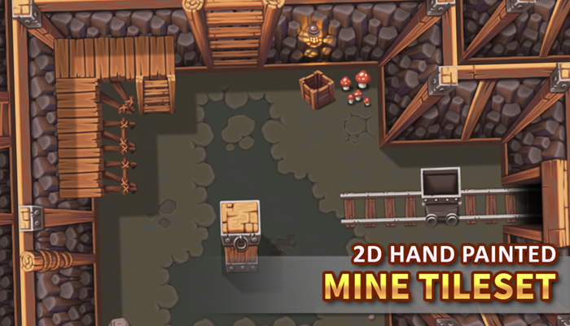This game design can include a design which include assets that are normally contained in a underground mine but in these case it is a dungeon that players need to escape the level by sliding to the correct blocks collecting points and finding the correct path to escape the level. It can also include minecarts that could transfer the main character to the next part of the dungeon. The level could also include big rocks that fall causing the character to lose lives.

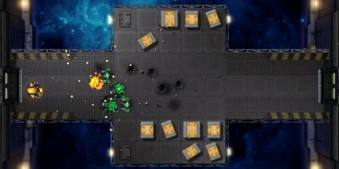

1. **Space Dungeon**

This game design could include an alien spacecraft in space where the character in game which could be a astronaut trying to escape the ship as his ship was captured and he was taken hostage. This level could include keys that the character could get to unlock doors to escape each of the levels in game while dodging enemies while also getting points in terms of coins or other any other design ideas.

The character should travel and slide to each of the supply boxes in the game that the aliens have stored their weapons inside which allows the character to progress through each of the levels as quickly as possible.

2D Sprite or 3D Model:

If 2D assets are used I will probably have to get them from the unity asset store as I do not have the best photoshop/art skills needed to make a decent 2D sprite that is used for the game we are making. An asset from the asset store may also be easier as its quicker and may include free assets that we can use.

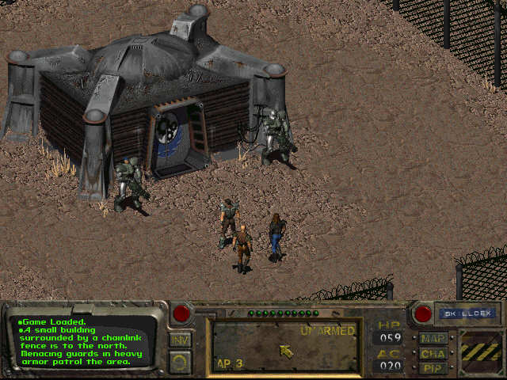2D asset creation will take more photoshop work but is a possible idea if both our game designers, design different parts of the level such as objects we need to collect and the main character in the game.

2D assets will also be easier to animate as it is one 2D sprite where we will just need to have a different sprite for each of the different animations for movement the main character will have. The game could also use a 2d Levels which can be easier to design in photoshop or other design software. But in 3d modelling we could use scatter and planes to make level but may take more time depending on how much time both our designers have spent in using 3ds max.

3D models could be used but may also take a lot of time and will have to be imported in Unity differently as we will be using 3DS max to important each 3D object individually. We can also use 3ds max to import 2D objects as well for the level plane and boundaries and other assets that are contained inside each of the levels in the game.